
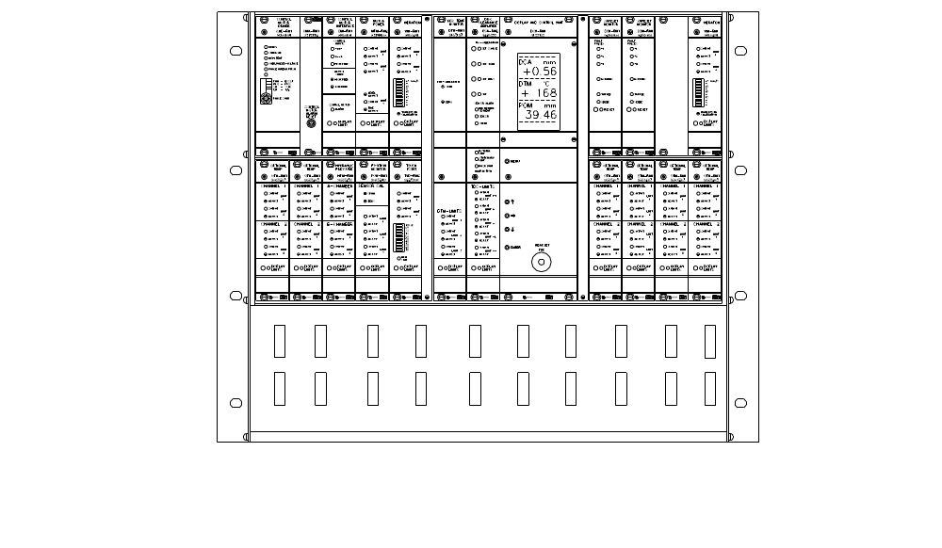

ENGLISH
DOCUMENTATION
R M S – D D 1

RMS-DD1 RMS DOUBLE DISC – DOCUMENTATION
MANUALS Date of revision
1. SYS-DD1 SYSTEM MANUAL RMS-DD Sept. 15, 2001
2. PAR-DD1 LIST OF PARAMETERS Oct. 1, 2004
3. CAL-DD1 CALIBRATION MANUAL April 3, 1996
4. PRO-DD1 PROGRAMMERS MANUAL June 3, 1998

USER MANUALS FOR THE RACK AND THE INCLUDED UNITS
5. RMS-DD1 DOUBLE DISC RACK May 2, 2007
6. CMD-RM1 CONTROL MOTOR DRIVER Feb. 4, 1995
CMD-RM2 CONTROL MOTOR DRIVER Oct. 1, 2004
CMI-RM1 CONTROL MOTOR INTERFACE Oct. 1, 2004
7. VIM-RM1 VIBRATION MONITOR June 6, 1998
MPM-RM2 MOTOR POWER MONITOR May 4, 1997
8. TVD-RM2 TOUCH POINT VIBRATION MONITOR Aug. 3, 1995
POM-RM1 POSITION MONITOR June 4, 1998
9. HPM-RM1 HYDRAULIC PRESSURE MONITOR Aug. 5, 1995
OTM-RM1 OPTIONAL TEMP MONITOR June 4, 1998
10. DCU-RM1 DISPLAY AND CONTROL UNIT Nov. 2, 2001
11. DCA-RM2 DISC CLEARANCE AMPLIFIER May 3, 1997
DTM-RM1 DISC TEMP MONITOR Feb. 4, 1995
12. SSM-RM1 SAFESET MONITOR June 4, 1995

USER MANUALS FOR THE ROTATING AND STATIONARY UNITS
13. RMS-DDS1 RMS-DD STATIONARY UNIT Aug. 3, 1995
RMS-DDR1 RMS-DD ROTATING UNIT April 3, 1996
14. TR-S RMS-DD STATIONARY TRANSFORMER Aug. 3, 1995
TR-RA70 RMS-DD ROTATING TRANSFORMER Aug. 3, 1995

USER MANUALS FOR THE PANEL DISPLAYS
15. PDU-RM4 PANEL DISPLAY UNIT Aug. 3, 1995
16. DSI-01 DIGITAL SIGNAL INDICATOR, 24VDC Feb. 18, 1995

USER MANUALS FOR THE TRANSDUCERS
17. TDC-DD TDC TRANSDUCER DD Sep. 30, 2005
18. POT-50 POSITION TRANSDUCER 50 mm Feb. 4, 1995
19. TVD-TA1 TOUCH POINT VIBRATION TRANSDUCER Aug. 3, 1995
20. VIM-T2 VIBRATION TRANSDUCER June 4, 1997
IG-30 INDUCTIVE TRANSDUCER SAFESET June 4, 1995

USER MANUALS FOR THE CABLES
21. K-DDRSC ROTATING CABLE Sep. 18, 2001
22. K-PDU3 CABLE PDU Feb. 4, 1995
K-POT25 CABLE POT Feb. 4, 1995
23. K-TVDS25 CABLE TVD-T Feb. 4, 1995
K-VIMS25 CABLE VIM April 4, 1997
K-AT10 CABLE SSM April 21, 1995
24. KB-01 CONNECTION BOX SAFESET Feb. 5, 1995
KB-03 CONNECTION BOX GENERAL Feb. 3, 1095
25. K- DDS25 CABLE DCA-TDC April 3, 1996
Latest date of revision May 2, 2007

3
PRODUCER

DAMETRIC AB
Jägerhorns Väg 19
SE-141 75 KUNGENS KURVA
SWEDEN

Phone
+46-(0)8-556 477 00
Telefax
+46-(0)8-556 477 29
E-mail
dametric@dametric.se
Internet
www.dametric.se

