
LIST OF PARAMETERS

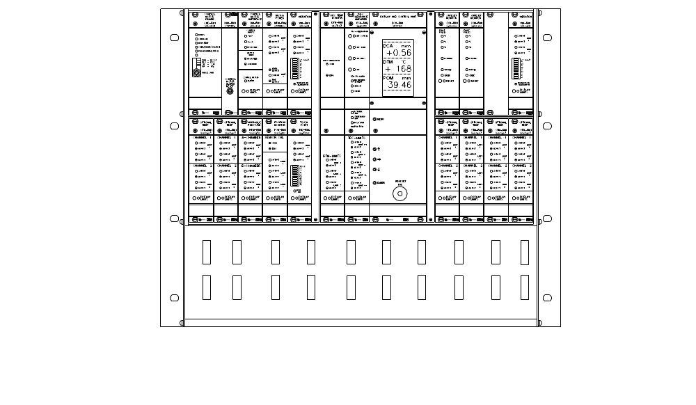
R M S – D D 1

Contents
1. DCU PARAMETERS 3
2. CMD-RM2 4
3. CMI-RM1 4
4. MPM-RM2 4
5. VIM-RM1, CONTROL SIDE 4
6. POM-RM1 5
7. TVD-RM2 5
8. DCA-RM2 5
9. DTM-RM1 5
10. HPM-RM1 6
11. OTM-RM1 / 1 (option unit) 6
12. OTM-RM1 / 2 (option unit) 6
13. OTM-RM1 / 3 (option unit) 7
14. OTM-RM1 / 4 (option unit) 7
15. OTM-RM1 / 5 (option unit) 7
16. OTM-RM1 / 6 (option unit) 8
17. SSM-RM1, CONTROL SIDE 8
18. SSM-RM1, FEEDING SIDE 8
19. VIM-RM1, FEEDING SIDE 8
20. RMS-DDR1 8
21. RMS-DDS1 8

DCU PARAMETERS
Unit serial no. _________ Hardware revision _________ Software revison _________
Menu 2, Activated units for the sum alarm check
Unit actual default
Disc temp. DTM - on
Hydr. Pressure HPM - off
Motor Power MPM - on
Opt. Temp -1 OTM-1 - off
Opt. Temp -2 OTM-2 - off
Opt. Temp -3 OTM-3 - off
Opt. Temp -4 OTM-4 - off
Opt. Temp -5 OTM-5 - off
Opt. Temp -6 OTM-6 - off
Rotorposition POM - on
Touchpoint TVD - on
Vibration VIMc - on
Vibration VIMf - on
Menu 3, Range setting Unit actual default
Motor Power MPM - 10.00 MW
POM Stroke POM - 50 mm
A-chamber Press HPM-A - 97 ton
B-chamber Press HPM-B - 160 ton
DCA Range DCA - 2.00 mm
RMS System RMS - DD
Menu 4, DCA calibration setting
Unit actual default
TVD Limit TVD - 50 %
POM Ratio POM - 1
Menu 5, Regulator setting actual default
Deadband - ±0.05 mm
Interval - 10 s
Gain - 100 %
Filter factor - 5 s
Over alarm - 50 %
Speed limit (over alarm) - 1.00 mm/h
Under alarm - 10 intervals
Low A-pressure - Enabled

Menu 11, Gap Guard settings actual default
Time - 2 s
Distance - 25 %
Gain - 100 %
Menu 6, Feed Guard settings actual default
Piston Length - 1.00 mm
Safe Distance - 1.00 mm
Timeout - 10 s
Menu 12, Display actual default
PDU - on

CMD-RM2
Unit serial no. _________ Hardware revision _________
DIP settings actual default function
4-pole dip switch in the front left right left right
1. Drive 1 Drive current 1
2. Drive 2 Drive current 2
3. Not used
4. Hold Hold current
No limit adjustments on this unit.

CMI-RM1
Unit serial no. _________ Hardware revision _________ Software revison _________
Dip settings actual default
Function off on off on
Adjust screw pitch SW2/1
Adjust screw pitch SW2/2
Not used SW2/3
Not used SW2/4
Speed adjustments actual default
Highspeed (H_sp) - 100 %
Lowspeed (L_sp) - 100 %

MPM-RM2
Unit serial no. _________ Hardware revision _________ Software revison _________
The nominal motor power is configured in the DCU-unit.
Dip settings actual default
off on off on
Use Limit 3 (Float) SW4/1
Not used SW4/2
Not used SW4/3
Not used SW4/4
Limit adjustments actual default (at 10.0 MW main motor power)
Low (L 1) - 4.0 MW
Lolow (L 2) - 2.0 MW
Floating (L 3 LEVEL) - 2.0 MW
Floating (L 3 TIME) - 3.0 s

VIM-RM1, CONTROL SIDE
Unit serial no. _________ Hardware revision _________
No dip settings on this unit.
Limit adjustments actual default
Limit 1 (L 1) - 10 mm/s
Limit 2 (L 2) - 8 mm/s

POM-RM1
Unit serial no. _________ Hardware revision _________
No dip settings on this unit.
Limit adjustments actual default
Limit 1 (L 1) - 38.50 mm
Limit 2 (L 2) - 30.00 mm
Limit 3 (L 3) - 28.00 mm

TVD-RM2
Unit serial no. _________ Hardware revision _________
Dip settings actual default
off on off on
Headset volume SW2/1
Headset volume SW2/2
Limit adjustments actual default
Limit 1 (L 1) - 75 %
Limit 2 (L 2) - 50 %

DCA-RM2
Unit serial no. _________ Hardware revision _________ Software revison _________
Dip settings actual default
off on off on
Sensitivity TVD High Gain SW8/1
Sensitivity TVD High Gain SW8/2
Sensitivity TVD Low Gain SW8/3
Sensitivity TVD Low Gain SW8/4

Enable push-buttons SW9/1
Not used SW9/2
Not used SW9/3
Calibration, DTM unit SW9/4
Limit adjustments actual default
Limit + + (L1) - 1.20 mm
Limit + (L2) - 1.00 mm
Limit - (L3) - 0.90 mm
Limit - L (L4) - 0.50 mm
Limit - - (L5) - 0.20 mm

DTM-RM1
Unit serial no. _________ Hardware revision _________
No dip settings on this unit.
Limit adjustments actual default
Limit 1 (L1) - 200 º
Limit 2 (L2) - 170 º
Limit 3 (L3) - 90 º

HPM-RM1
Unit serial no. _________ Hardware revision _________
No dip settings on this unit.
Limit adjustments actual default (with 97/160 ton HPM-setting)
A-chamber pressure, Limit 1 - 39 ton
A-chamber pressure, Limit 2 - 19 ton
B-chamber pressure, Limit 1 - 64 ton
B-chamber pressure, Limit 2 - 32 ton
Unit serial no. _________ Hardware revision _________

OTM-RM1 / 1 (option unit)
Unit serial no. _________ Hardware revision _________
Dip settings actual default (100°C)
off on off on
SW1/1
SW1/2
SW1/3
SW1/4
All 4 must either be off or on: 100 °C - set all to off, 200 °C - set all to on.
Limit adjustments actual default (at 100°C range)
Channel 1, Limit 1 (C1L1) - 60 °C
Channel 1, Limit 2 (C1L2) - 55 °C
Channel 2, Limit 1 (C2L1) - 60 °C
Channel 2, Limit 2 (C2L2) - 55 °C

OTM-RM1 / 2 (option unit)
Unit serial no. _________ Hardware revision _________
Dip settings actual default (100°C)
off on off on
SW1/1
SW1/2
SW1/3
SW1/4
All 4 must either be off or on: 100 °C - set all to off, 200 °C - set all to on.
Limit adjustments actual default (at 100°C range)
Channel 1, Limit 1 (C1L1) - 60 °C
Channel 1, Limit 2 (C1L2) - 55 °C
Channel 2, Limit 1 (C2L1) - 60 °C
Channel 2, Limit 2 (C2L2) - 55 °C

OTM-RM1 / 3 (option unit)
Unit serial no. _________ Hardware revision _________
Dip settings actual default (100°C)
off on off on
SW1/1
SW1/2
SW1/3
SW1/4
All 4 must either be off or on: 100 °C - set all to off, 200 °C - set all to on.
Limit adjustments actual default (at 100°C range)
Channel 1, Limit 1 (C1L1) - 60 °C
Channel 1, Limit 2 (C1L2) - 55 °C
Channel 2, Limit 1 (C2L1) - 60 °C
Channel 2, Limit 2 (C2L2) - 55 °C

OTM-RM1 / 4 (option unit)
Unit serial no. _________ Hardware revision _________
Dip settings actual default (100°C)
off on off on
SW1/1
SW1/2
SW1/3
SW1/4
All 4 must either be off or on: 100 °C - set all to off, 200 °C - set all to on.
Limit adjustments actual default (at 100°C range)
Channel 1, Limit 1 (C1L1) - 60 °C
Channel 1, Limit 2 (C1L2) - 55 °C
Channel 2, Limit 1 (C2L1) - 60 °C
Channel 2, Limit 2 (C2L2) - 55 °C

OTM-RM1 / 5 (option unit)
Unit serial no. _________ Hardware revision _________
Dip settings actual default (100°C)
off on off on
SW1/1
SW1/2
SW1/3
SW1/4
All 4 must either be off or on: 100 °C - set all to off, 200 °C - set all to on.
Limit adjustments actual default (at 100°C range)
Channel 1, Limit 1 (C1L1) - 60 °C
Channel 1, Limit 2 (C1L2) - 55 °C
Channel 2, Limit 1 (C2L1) - 60 °C
Channel 2, Limit 2 (C2L2) - 55 °C

OTM-RM1 / 6 (option unit)
Unit serial no. _________ Hardware revision _________
Dip settings actual default (100°C)
off on off on
SW1/1
SW1/2
SW1/3
SW1/4
All 4 must either be off or on: 100 °C - set all to off, 200 °C - set all to on.
Limit adjustments actual default (at 100°C range)
Channel 1, Limit 1 (C1L1) - 60 °C
Channel 1, Limit 2 (C1L2) - 55 °C
Channel 2, Limit 1 (C2L1) - 60 °C
Channel 2, Limit 2 (C2L2) - 55 °C

SSM-RM1, CONTROL SIDE
Unit serial no. _________ Hardware revision _________ Software revison _________
Dip settings actual default
off on off on
Rotation time SW2/1
Reset SW2/2
Not used SW2/3
Not used SW2/4

Fault pulses (0-9) SW3 - 4

SSM-RM1, FEEDING SIDE
Unit serial no. _________ Hardware revision _________ Software revison _________
Dip settings actual default
off on off on
Rotation time SW2/1
Reset SW2/2
Not used SW2/3
Not used SW2/4

Fault pulses (0-9) SW3 - 4

VIM-RM1, FEEDING SIDE
Unit serial no. _________ Hardware revision _________
No dip settings on this unit.
Limit adjustments actual default
Limit 1 (L 1) - 10 mm/s
Limit 2 (L 2) - 8 mm/s

RMS-DDR1
Unit serial no. _________ Hardware revision _________ Software revison _________

RMS-DDS1
Unit serial no. _________ Hardware revision _________ Software revison _________

